

Sealy FFA Handbook
2008-2009
FFA Motto:
Learning to Do,
Doing to Learn
Earning to Live,
Living to Serve
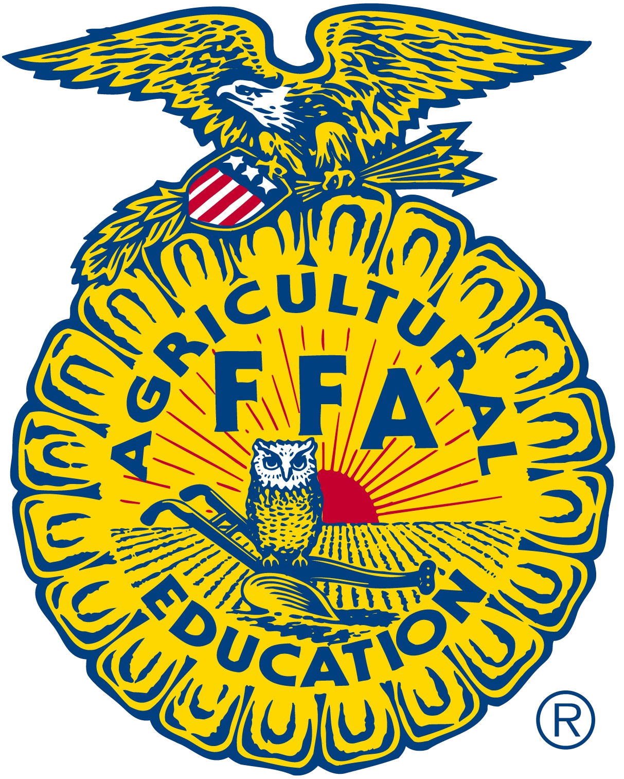

Sealy FFA Chapter Goals
- Improve night and homeroom period meetings.
- Get members more involved in community service.
- More dedication to LDE’s and CDE’s.
- Improve attendance and member involvement.
- Give back to our community.

2008-2009 Sealy FFA Officer Team
President Preston Gates
Vice President Gabby Luetge
Secretary Ryan Pacher
Treasurer Reid Richardson
Reporter Matt Kana
Sentinel Kaylee Nelson

Advisors: Meredith Cook
J.P. Hancock
SEALY FFA
Where you don’t have to be the best in the world; You just have to give the world your BEST!

FFA Membership
FFA makes a positive difference in the lives of students by developing their premiere leadership, personal growth and career success through agriculture education.

FFA Dues:
- $20.00 includes National, State, Area, District and Chapter Dues
- Includes FFA bag
- Deadline to pay dues is Oct. 3rd
- You will not be able to participate in any FFA activities unless you have paid your dues.

FFA Meetings:
September 17th
October 21st
November 18th
December 16th
All meetings are at 7:00 in Ms. Cook’s classroom

* Anyone that has a behavior problem at a meeting will be asked to leave and will not be allowed to attend a meeting without there parents attending with them.
Involvement Incentives

Fundraisers:
- For every 10 items you sell your name is placed in a drawing for a ticket to the Houston Arrows game on January 23rd.
- Sell 50 items (as a Greenhand) and receive your FFA jacket for free.
- Sell 30 items (as a 2nd, 3rd, or 4th year member) and receive a Sealy FFA sweatshirt
- For every 2 hours worked at the coke stand your name is placed in a drawing for a ticket to the Houston Arrows game on January 23rd.
- 1st place seller of fruit and meat – belt buckle
- 2nd place seller of fruit and meat - $100 gift card
- 3rd place seller of fruit and meat - $75 gift card

Sealy FFA will give away 25 free tickets for the Houston Arrows game.

“FFA Member Lives Here”

FFA members who complete or attend the 4 following activities and who have paid their dues will receive an FFA Member Lives Here sign to display at their Home.

- Come to the September meeting
- Come to the October meeting
- Work 2 shifts at the Austin County Fair Coke Stand
- Sell 10 items in the FFA fundraiser

Name ______________________________________________
Yes, I attended all the FFA activities needed to receive me FFA sign
Student’s Signature ______________________________
Officer’s Signature ________________________________
All FFA Activities:

Will be on the calendar in Ms. Cook’s Room
Will have a sign up sheet on Ms. Cook’s Door
Will be on the board in Mr. Hancock’s Room
Will be on the School Website

